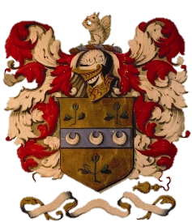
CHRISTMAS LUNCH AT DALEMAIN
Pre-Order Form 2023

Served Thursday 30th November-Monday 18th December
(Sunday-Thursday) at 12-2.15pm

Booking Details

Name
Contact Number/Email
Total in Party
Date of Lunch
Time of Arrival
How Did You Hear About Us?

Menu Choices
Please advise us of numbers required beside each dish, as well as noting any dietary requirements

 | Number | Dietary Requirements
Kitchen Garden Leek and Sweet Potato Soup with Winter Spices (GF)
Served with a Chive Scone
Chicken Liver and Brandy Pate
Served with our Beetroot & Apple Chutney and a Freshly Baked Baguette
Trio of Melon and Mint Fruit Cocktail (GF) (VE)
Locally Reared Roast Turkey
With Homemade Stuffing, Yorkshire Pudding & Chipolata Sausage
Rich Dalemain Venison Casserole in Red Wine
Served with a Yorkshire Pudding
Lentil and Vegetable Lasagne (V)

Traditional Christmas Pudding
Served with Brandy Sauce
Dalemain Special Celebration Trifle
With Rhubarb and Strawberries
Meringue Christmas Wreath
With Berries and Cream

Please return the completed Pre-Order Form and a £10 per person deposit at least 2 weeks before the date of your meal. We will then confirm your place is booked, with the remaining balance to be paid on the day.

Completed forms can be returned to Dalemain Mansion, Dalemain, Penrith, CA11 0HB, or emailed to tourism@dalemain.com. For more information, please call us on 017684 86450, or visit the website: www.dalemain.com.

